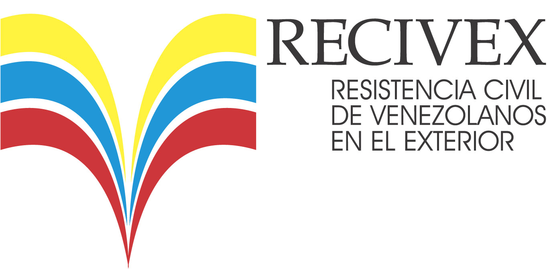
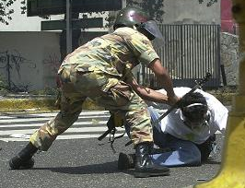
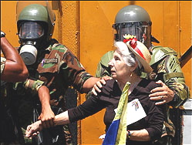
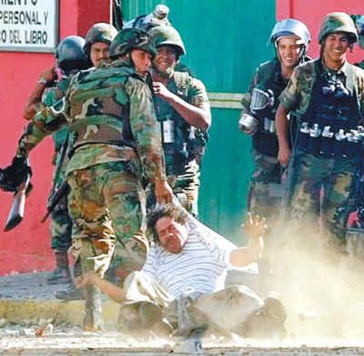
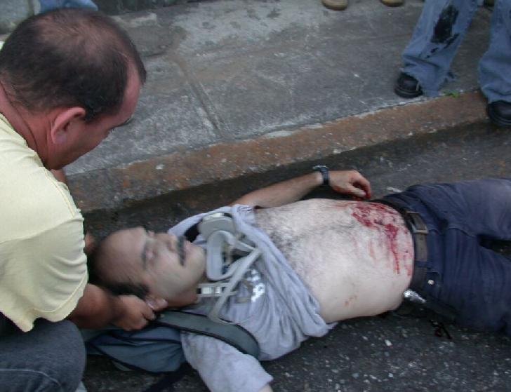
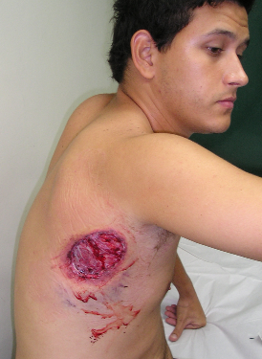
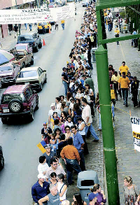
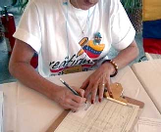
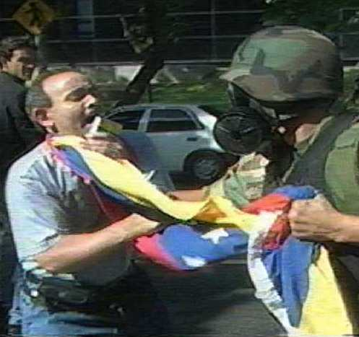
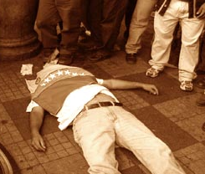
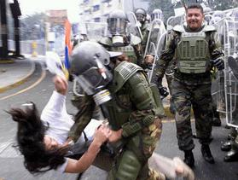


Produced by AVENDED
Association of Venezuelans in Defense of Democracy
www.avended.org
contact@avended.org
Venezuelans who
oppose president

Chávez collected
millions of signatures
(several times) to
activate a referendum for a presidential recall, as established in the constitution. After one year of struggle against a visibly biased National Electoral Council (NEC), the referendum finally occurred in August 2004. For the first time in Venezuelan history, the result was based solely on the voting machines that the NEC insisted in purchasing. According to official results, president Chávez’s mandate was confirmed by majority. Now the government is using the lists of Venezuelans who signed the petition to threaten and prosecute dissidents. Those who signed the petition are banned from working or doing business with institutes or companies controlled by the state. (State Oil Industry, Governmental Offices, etc.).

These faces and names belong to real people. They are just a few examples of the victims of Chávez’s regime.
Hundreds of Venezuelans have been wounded and imprisoned. Tens have been tortured and murdered…
José M. Vilas, an ex employee of the oil industry, was killed with two FAL (self-loading rifle) shots that hit him on the back.
"History will have to record that the greatest tragedy of this period of social transition was not the strident clamor of the bad people, but the appalling silence of the good people"
Martin Luther King, Jr.

Although Chávez was elected democratically, his regime is NOT a democracy anymore!

Pedro Martin (above) surrendered
to the soldiers. Instants later
he was shot with a shotgun
at point-blank range.

April 11, 2002 - April 11, 2005
THREE YEARS OF HUMAN RIGHTS VIOLATIONS IN VENEZUELA
AN
ENDANGERED
DEMOCRACY
(CIVIL RESISTANCE OF VENEZUELANS ABROAD)
www.recivex.com
1
6
5

